Nov5 :
Task1:
use nov5;

SELECT * FROM Worker WHERE SALARY > 100000;

SELECT * FROM Worker WHERE SALARY <= 90000;

SELECT * FROM Worker WHERE SALARY >= 300000;
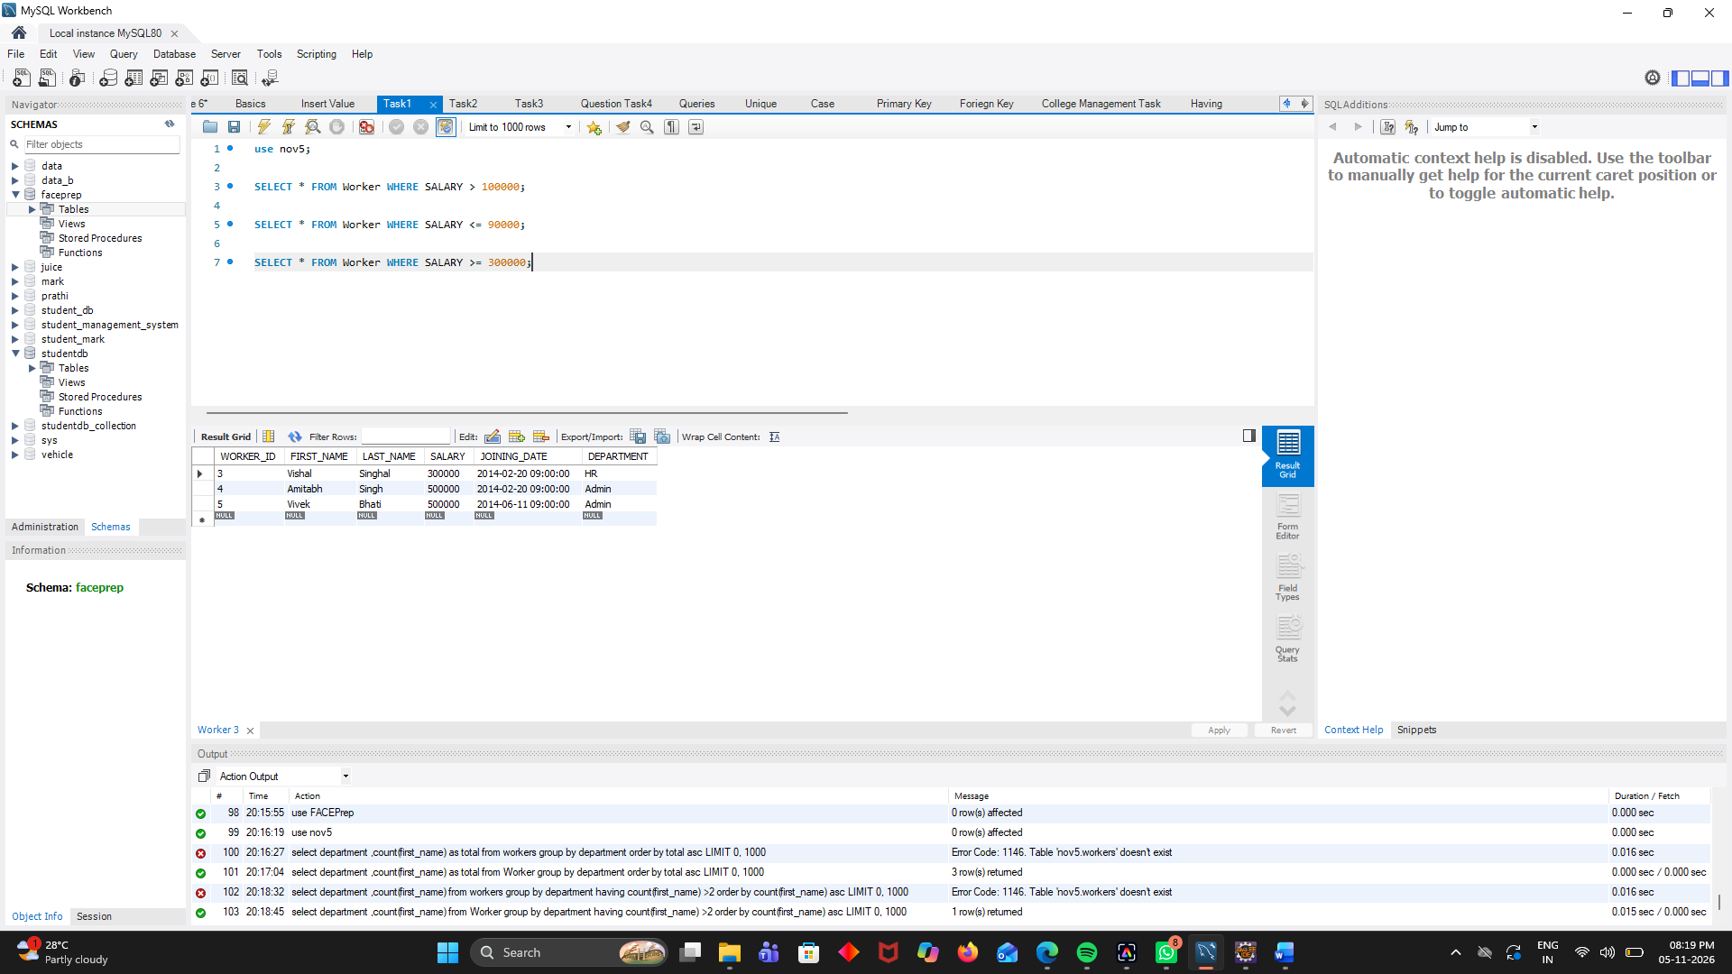

Task2:
use nov5;

SELECT * FROM Worker WHERE DEPARTMENT = 'HR' AND SALARY > 100000;

SELECT * FROM Worker WHERE DEPARTMENT = 'Admin' OR DEPARTMENT = 'Account';

SELECT * FROM Worker WHERE NOT DEPARTMENT = 'HR';
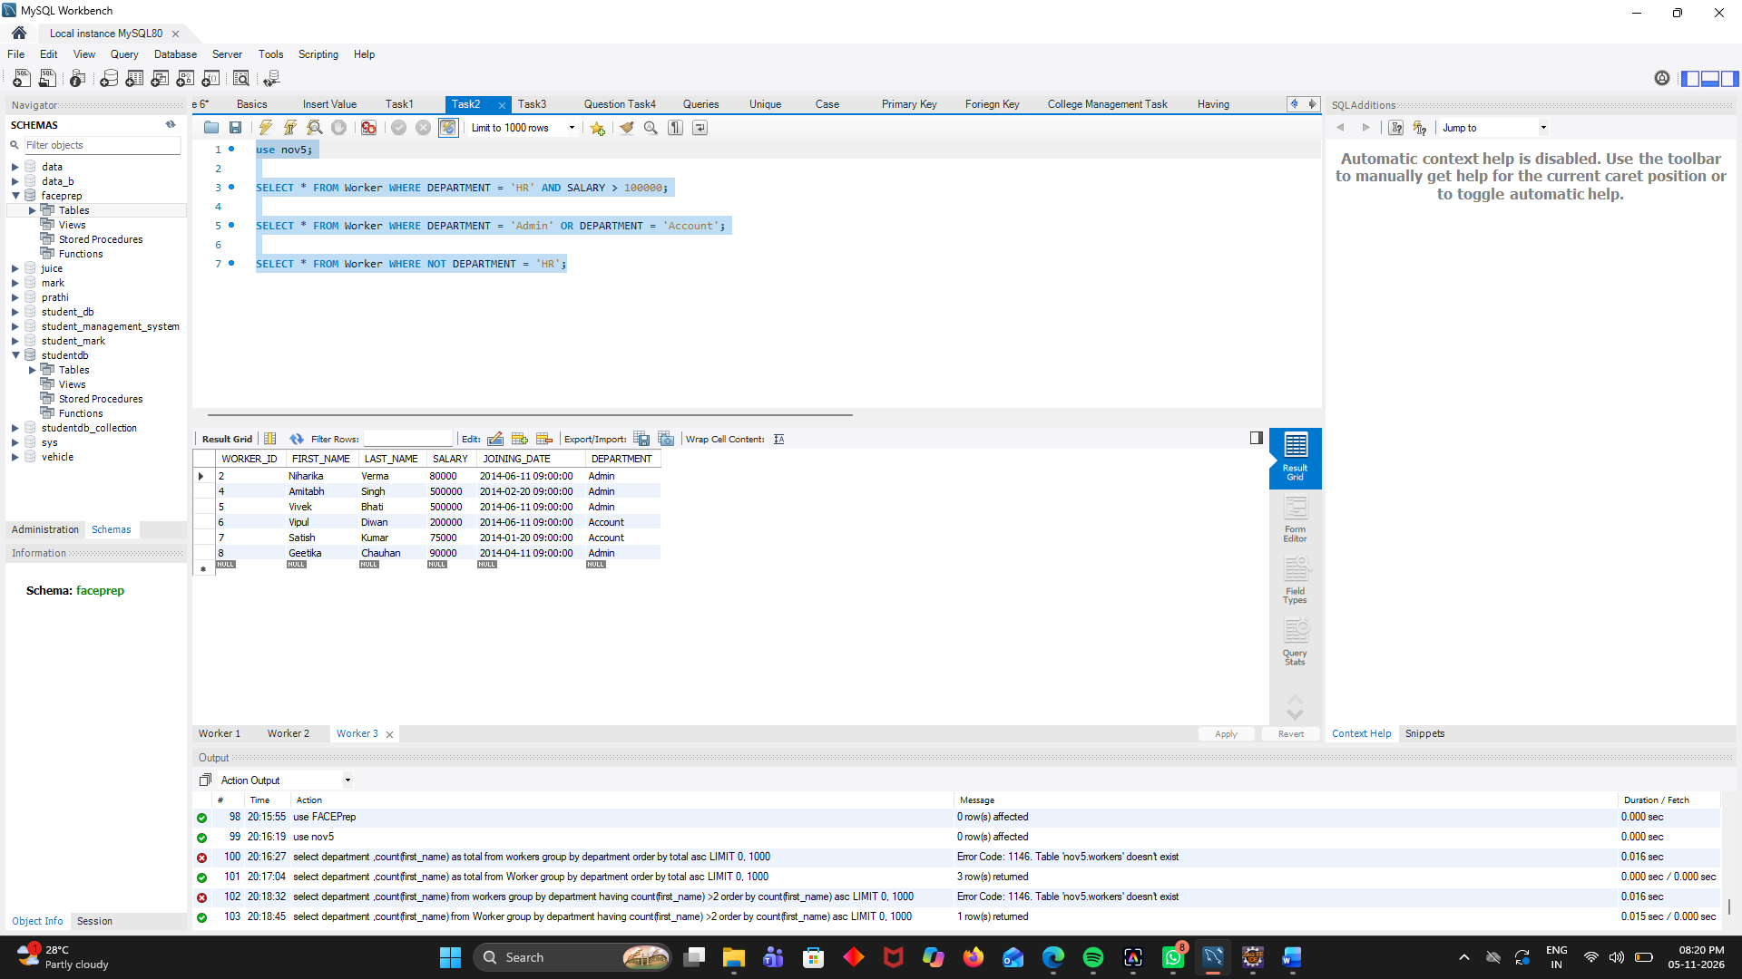

Taks3:
use nov5;

SELECT * FROM Worker WHERE DEPARTMENT IN ('HR', 'Admin', 'Account');

SELECT * FROM Worker WHERE SALARY BETWEEN 80000 AND 300000;

SELECT * FROM Worker WHERE FIRST_NAME LIKE 'V%';

SELECT * FROM Worker WHERE LAST_NAME LIKE '%a';
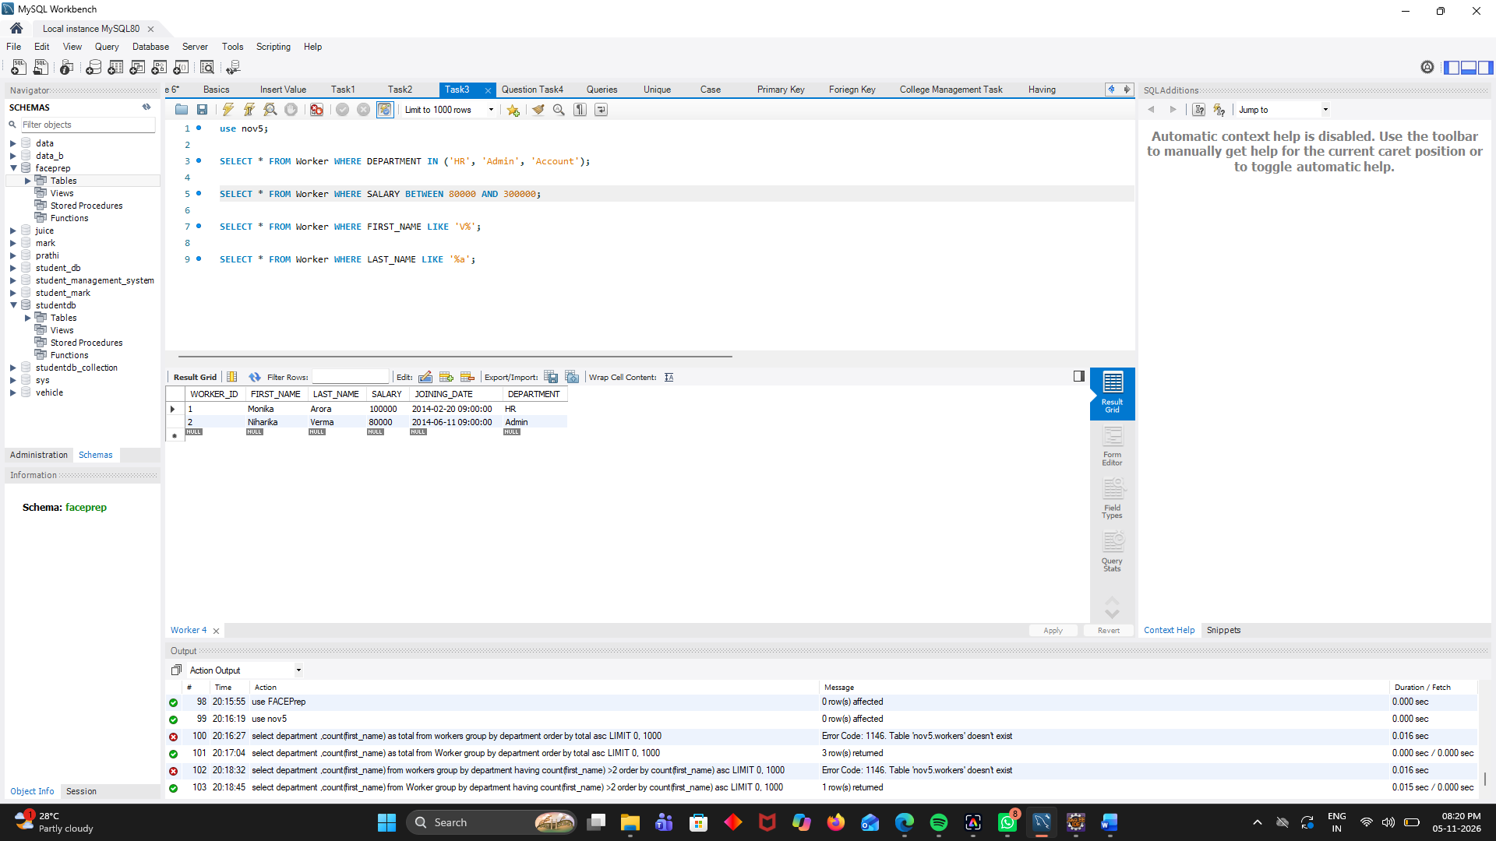

Questins Task4:
use nov5;

SELECT DEPARTMENT, SUM(SALARY) AS TOTAL_SALARY FROM Worker GROUP BY DEPARTMENT ORDER BY TOTAL_SALARY DESC;

SELECT DEPARTMENT, AVG(SALARY) AS AVERAGE_SALARY FROM Worker GROUP BY DEPARTMENT ORDER BY AVERAGE_SALARY ASC;

SELECT DEPARTMENT, COUNT(*) AS TOTAL_WORKERS FROM Worker ORDER BY TOTAL_WORKERS DESC;

SELECT DEPARTMENT, MIN(SALARY) AS MINIMUM_SALARY FROM Worker GROUP BY DEPARTMENT ORDER BY MINIMUM_SALARY ASC;

SELECT DEPARTMENT, COUNT(*) AS TOTAL_WORKERS, MAX(SALARY) AS MAX_SALARY,MIN(SALARY) AS MIN_SALARY FROM Worker GROUP BY DEPARTMENT;

SELECT DEPARTMENT, SUM(SALARY) AS TOTAL_SALARY, AVG(SALARY) AS AVERAGE_SALARY FROM Worker GROUP BY DEPARTMENT;

SELECT DEPARTMENT, COUNT(*) AS TOTAL_WORKERS, AVG(SALARY) AS AVERAGE_SALARY FROM Worker GROUP BY DEPARTMENT ORDER BY AVERAGE_SALARY DESC;

SELECT DEPARTMENT, MAX(SALARY) AS HIGHEST_SALARY, MIN(SALARY) AS LOWEST_SALARY FROM Worker GROUP BY DEPARTMENT ORDER BY HIGHEST_SALARY DESC;

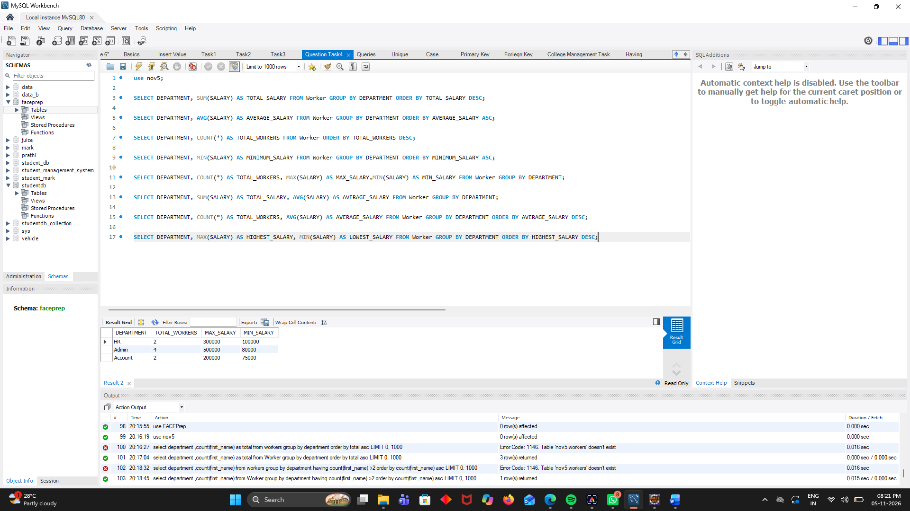

Having:

use nov5;
select department ,count(first_name) as total from Worker group by department order by total asc;

select department ,count(first_name) from Worker group by department having count(first_name) >2 order by count(first_name) asc;



